My Projects

Find My Phone (Clap/Whistle) using Tensorflowlite & MVVM Pattern

Network Info Mobile App using Providers, Hive DB & MVVM Pattern

Weather App

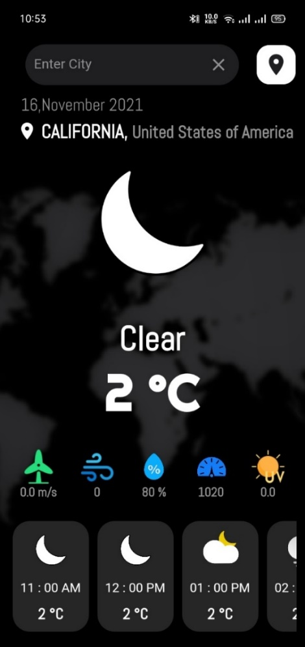
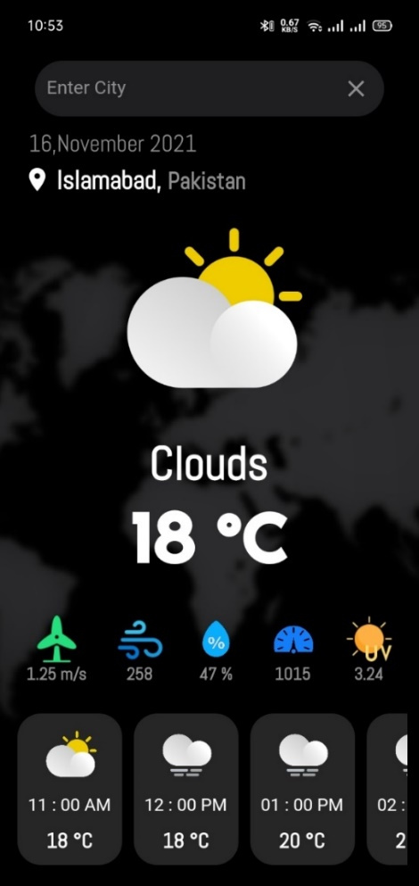
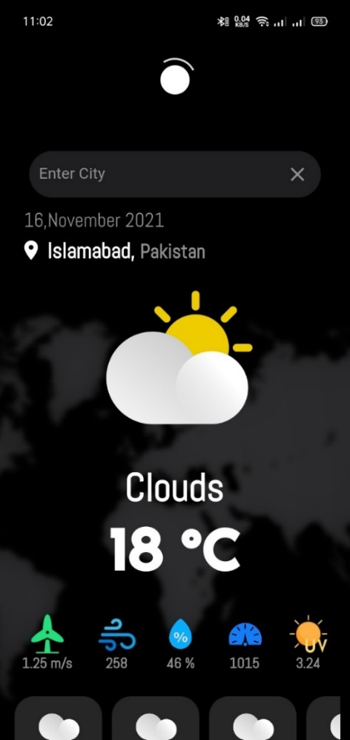
Features
- Fetch current weather using current location
- Fetch current weather using city name
- Fetch next 12 hours weather prediction.
- Display icons according to day/night.
- Display Cached weather if no internet.

What I used
- BLOC/Cubit State Management
- Geo Location
- API Integration
- Network Connection State

Weather through city Search Screen
App Home Screen
Pull to Refresh Weather
Blood Donation App
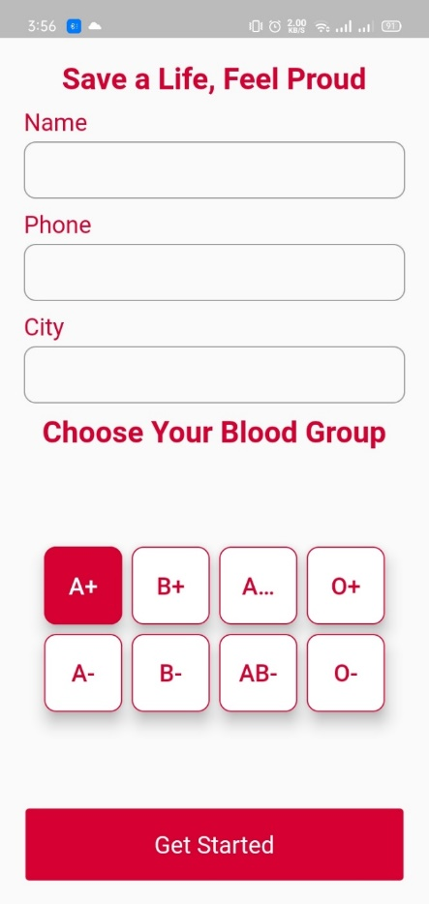
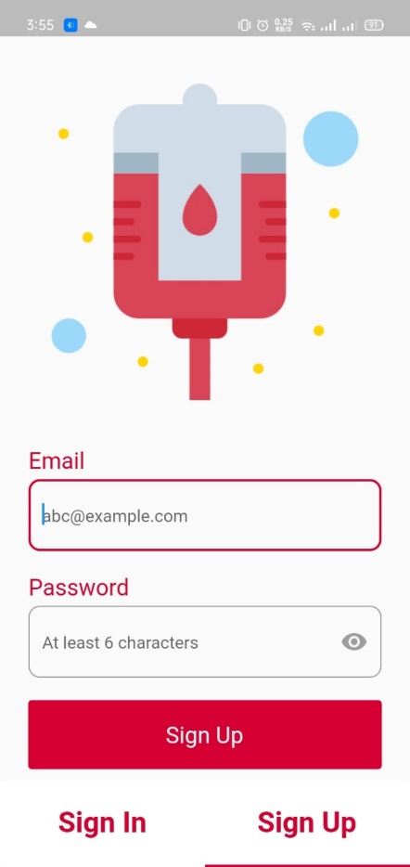
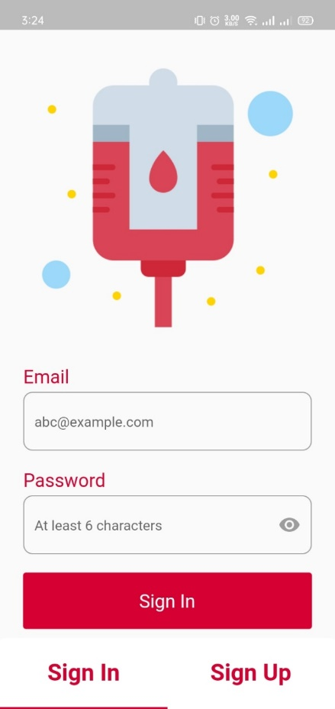
Sign Up Details Screen
Sign Up Screen
Sign In Screen
Features
- User Sign In/ Sign Up.
- User can browse all blood requests as well as filter those requests.
- User can add blood request.

What I used
- Providers State Management
- Firebase Auth
- Firebase Firestore.
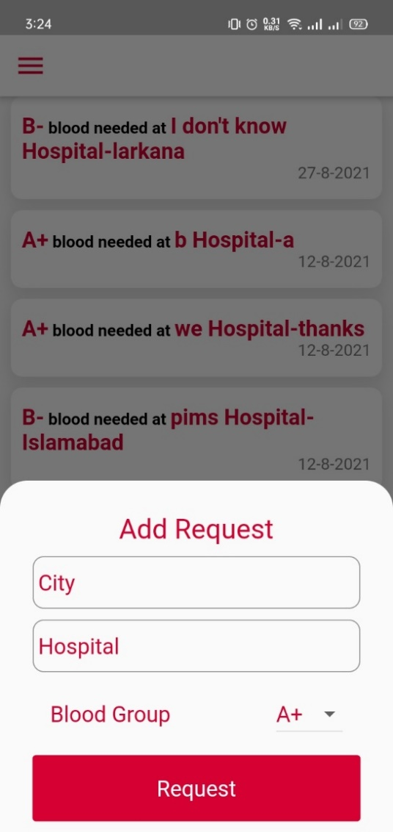
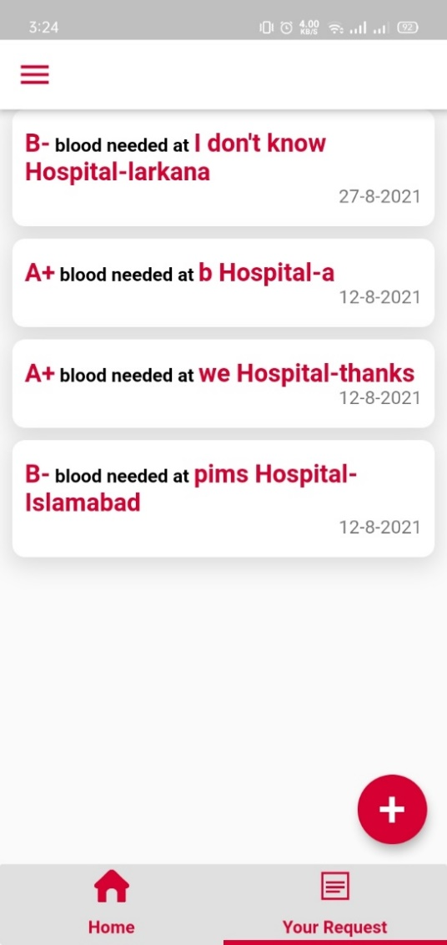
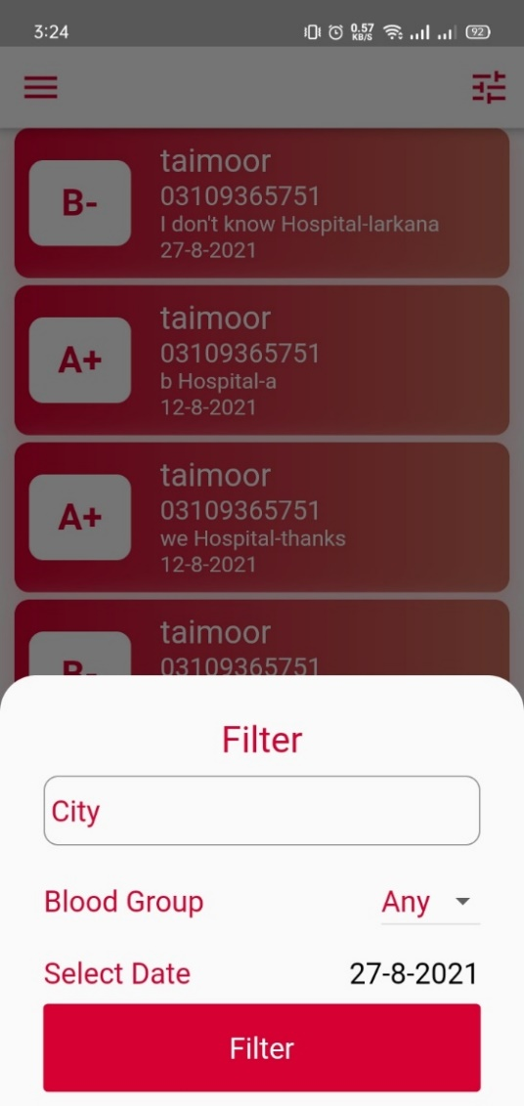
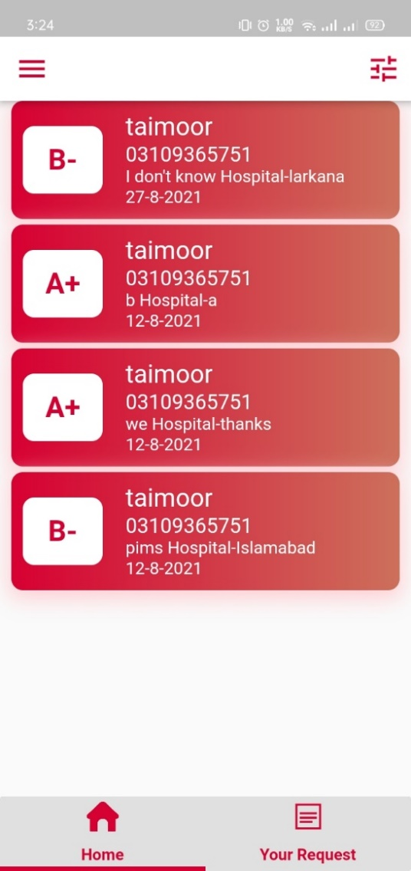
User Add New Request Model Sheet
User Requests Screen
Requests Filtering Model Sheet
Blood Requests Browsing Screen
Covid Tracker App
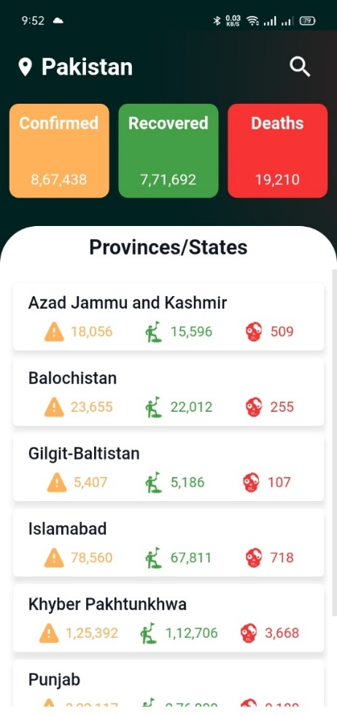
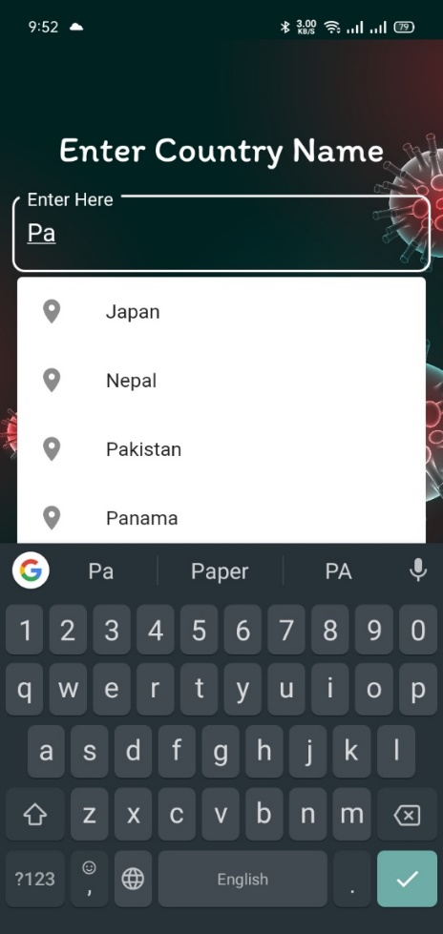
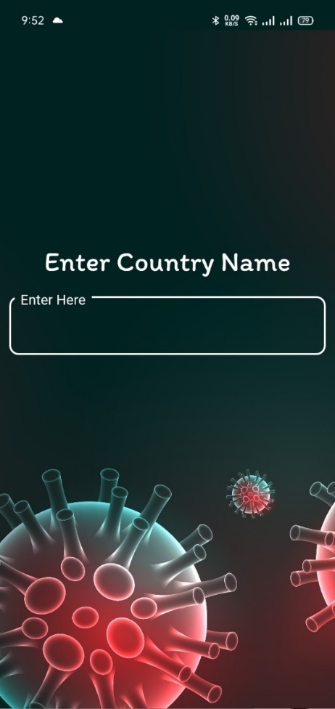
Country Statistics with states/provinces Dashboard Screen
Auto Complete Textfield
Country Search Screen
Features
- Fetch covid statistics using current location of user.
- Fetch covid statistics using country search.
- Display all states/provinces statistics of the country.

What I used
- BLOC/Cubit State Management.
- API Integration.
- Auto Complete Text Field.
- Splash Screen.
- Shared Preferences.
Todo App
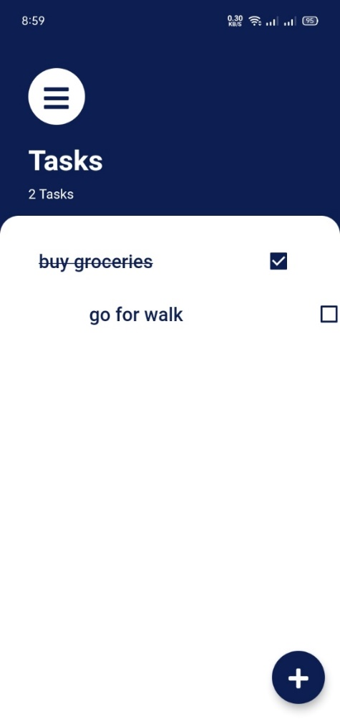
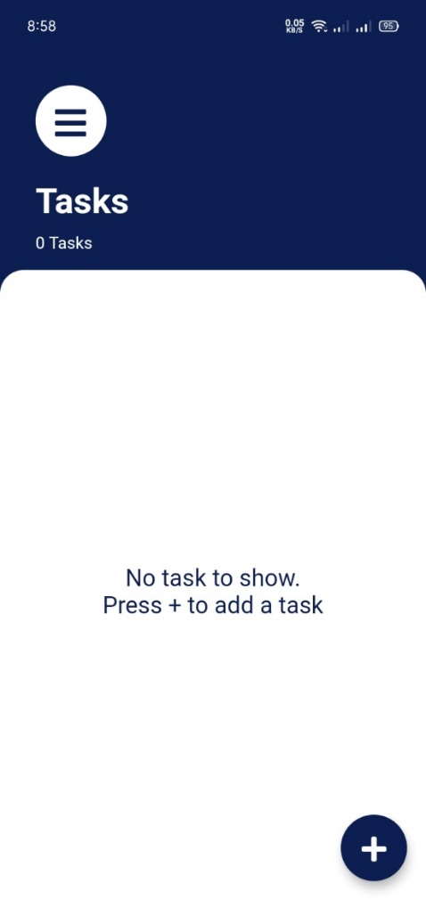
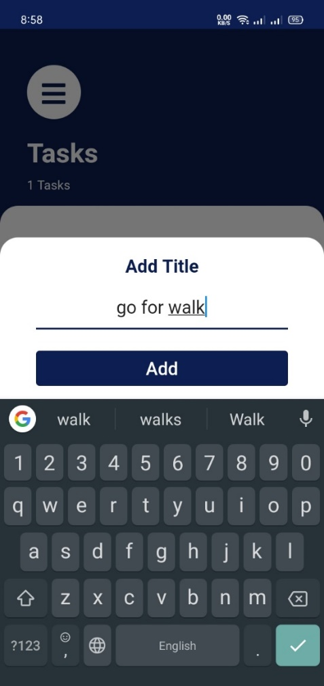
Tasks Screen
Delete Task by Sliding it
Features
- Add or delete task.
- Mark as completed.
What I used
- Provider State Management.
- Sqflite Local Database.
Add New Task Model Sheet
Music App (UI Only)
